Chapter 7 Wave–particle duality and quantum theory
Chapter Test Answers Total marks 47
Question 1
State two pieces of evidence that support the wave nature of light. For one of these pieces of evidence, explain how it provides evidence for the wave nature of light. Diagrams may be used to assist your explanation. (4 marks)

Description | Marks
Evidence supporting the wave nature of light may include:  - interference patterns for light passing through a double slit  - refraction of light  - dispersion of light  - diffraction of light  - polarisation of light  - the Doppler effect. | 2 (1 for each)
Explanation | 2
- Interference patterns for light passing through a double slit: appearance of nodes and antinodes suggesting the destructive and constructive interaction of waves, respectively, after passing through the slits.
- Refraction of light: the change in direction of light as it passes from a medium of one optical density into a second of differing optical density due to a change in the light’s speed is analogous to other waves such as sound.
- Dispersion of light: the splitting of white light into its component colours as it passes through a triangular glass prism is explained by the slowing of the waves by different amounts and that each wavelength changes by a different amount. Each wave is travelling at a different speed and so they bend by different amounts.
- Diffraction of light: light changes direction as it passes through an opening or encounters an obstacle. This is analogous to other waves such as water or sound waves.
- Polarisation of light: light waves oscillate in perpendicular planes. A polarising filter allows only one plane to pass through reducing the intensity of the emitted light.
- The Doppler effect: increase in frequency of light as it moves towards an observer, or decrease in frequency of light as it moves away from an observer, is analogous to the change in frequency of sound waves as they move towards or away from an observer, suggesting that light is wave-like.

Question 2
Which one of the following statements about the photoelectric effect is correct?
A The kinetic energy of electrons ejected from a metal surface will increase as the intensity of light incident on the surface is increased.
B The minimum energy of a photon needed to eject an electron from a metal surface varies with the frequency of the incident light.
C For light above the required minimum frequency, an increase in the intensity of the incident light on a metal surface will increase the number of electrons ejected from its surface.
D The photoelectric effect is used as evidence to support the model of light as a transverse electromagnetic wave.
Explain why you think the answer you have chosen is correct. (3 marks)

Description | Marks
Correct alternative is C | 1
An increase in intensity represents an increase in the number of photons of light striking the surface, so more electrons are ejected by the higher number of photons. | 2

Question 3
When ordinary white light is looked at through a single polarising sheet, the brightness of light passing through to the observer is reduced by about half. A second polarising sheet can be placed on top of the first sheet in such a way as to have no effect on the brightness of the light passing through. If the second sheet is now rotated 90°, virtually no light now passes through to the observer.
Explain these observations using the appropriate physics principles. (4 marks)

Description | Marks
Recognition that the original white light is unpolarised | 1
Recognition that the polarising sheet polarises the light by allowing only light in one plane of polarisation to pass through and so reduces the brightness by about half (depending on the quality of the polarising filter) | 1
Recognition that when the second polarising sheet is placed on top of the first, its polarising material has the same orientation as the polarising material in the first sheet and so continues to allow the same amount of light to pass through. Thus, brightness is unaffected. | 1
Recognition that when the second polarising sheet is rotated 90°, its polarising material is now orientated 90° to that of the polarising material in the first sheet so it blocks the remaining light allowing virtually none to pass through | 1

Question 4
Use the information below to answer the questions that follow.
At its simplest, a mobile telephone is a radio transmitter and receiver. When we speak into our mobile phone, the audio signal is converted to an electrical signal by a transducer. The electrical signal is called an audio frequency because its frequencies are in the audio range of 20 to 20 000 Hz, which are of the same frequencies as the audio signals. The oscillating electrons from the alternating current of the electrical signal travel to the transmitting antenna where they are converted to electromagnetic (EM) waves.
The electromagnetic waves from the sender’s phone are picked and relayed on by the mobile telephone towers in the network until they reach the receiver’s telephone. The antenna in the receiver’s phone picks up the electromagnetic waves, which cause the electrons in the receiving antenna to oscillate creating an electrical signal. This signal is converted back to an audio signal heard by the person receiving the telephone call.

a Compare the frequency of oscillations of the electrons in the transmitting antenna to the frequency of the electromagnetic waves sent out by the transmitting antenna. (1 mark)

Description | Marks
The frequency of the EM waves is the same as the frequency of oscillation in the transmitting antenna. | 1

b Compare the frequency of oscillations of the electrons in the transmitting antenna to the frequency of the oscillation of electrons in the receiving antenna. (1 mark)

Description | Marks
The frequency of the oscillation of electrons in the receiving antenna is the same as the frequency of oscillation in the transmitting antenna. | 1

c What is the wavelength of an EM wave resulting from an electrical signal with the maximum audio frequency? (2 marks)

Description | Marks
c = λf | 2

d The EM wave generated by the audio input in a phone is carried by a carrier wave. For many mobile networks in Australia, the frequency of the carrier wave is in the 850 MHz band.
i Identify whether the wavelength for an EM wave generated by an audio input at the maximum audio frequency or the wavelength of the carrier wave.
ii Determine by which magnitude (factor) it is longer. (2 marks)

Description | Marks
i Recognition that there is a longer wavelength for higher frequency, so audio-generated EM has the longer wavelength | 1
ii  That is, the EM wave for the audio-generated signal is 42 500 times longer than the carrier wave. | 1

Question 5
Ultraviolet light with a frequency of 1.46 × 10¹⁵ Hz is shone onto the surface of an unknown element. Electrons with a kinetic energy of 1.22 eV are measured being emitted from the surface of the element. From the list of elements below, identify which is the unknown element. Show clear working to support your answer. (5 marks)

Element | Work function (eV)
aluminium | 4.08
beryllium | 5.00
boron | 4.45
carbon | 4.81
gallium | 4.32
manganese | 4.10

Description | Marks
Energy of electrons in joules = 1.22 × 1.6 × 10⁻¹⁹ = 1.952 × 10⁻¹⁹ J | 1
W = hf − E_{k}  = (6.63 × 10⁻³⁴ × 1.46 × 10¹⁵) – (1.952 × 10⁻¹⁹)  = 7.73 × 10⁻¹⁹ J | 2
 | 1
The element is carbon. | 1

Question 6
If a beam of white light is shone through a sample of oxygen gas as illustrated below and the emergent light examined through a spectroscope, rather than a continuous spectrum being observed, there will be a series of dark lines in the spectrum. Explain what causes this series of dark lines. (3 marks)
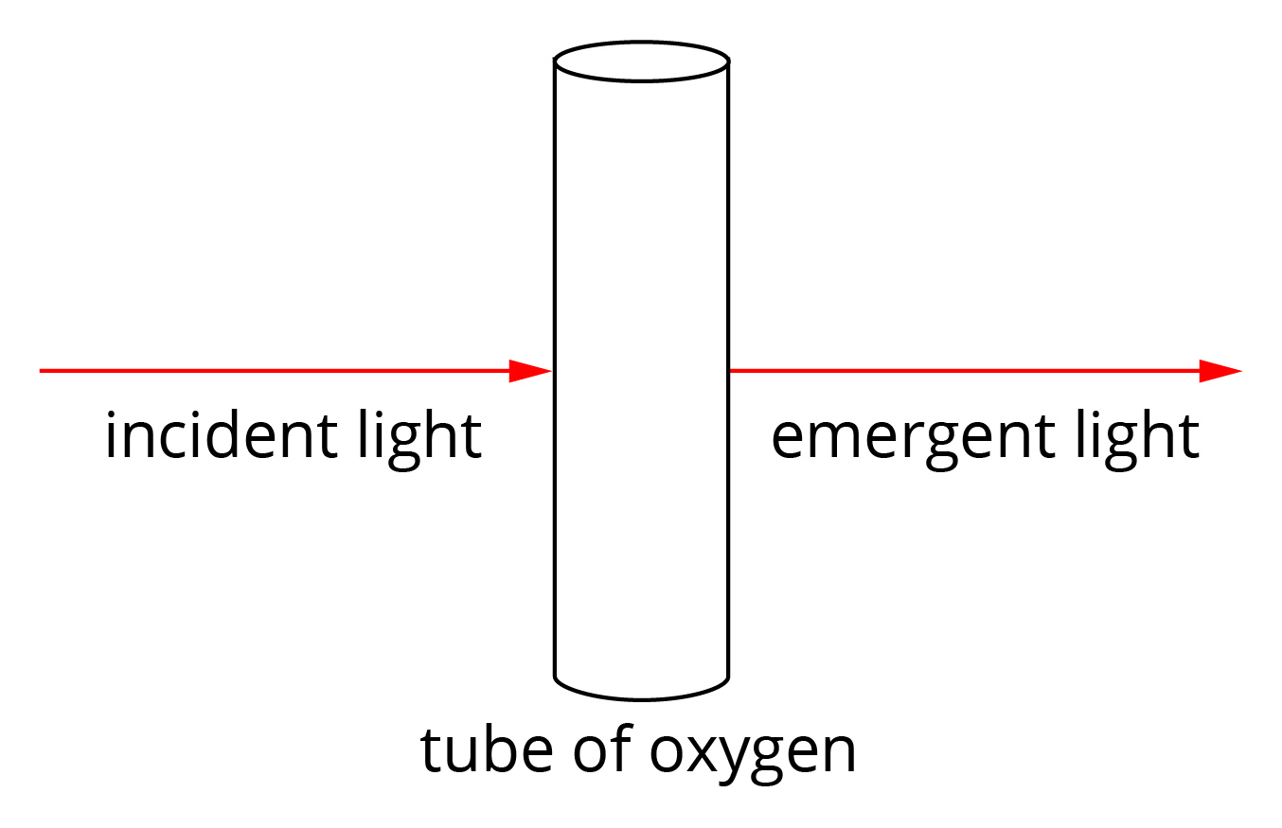

Description | Marks
The energy of the incident light is absorbed by electrons in the oxygen to excite them to higher energy levels. | 1
These energies correspond to transitions of ground state electrons to higher energy levels. | 1
Each transition absorbs light of a specific wavelength (or frequency) in the spectrum of the white light which leaves these as dark lines in the spectrum of the emergent light. | 1

Question 7
The diagram below shows some of the energy levels for a mercury atom.

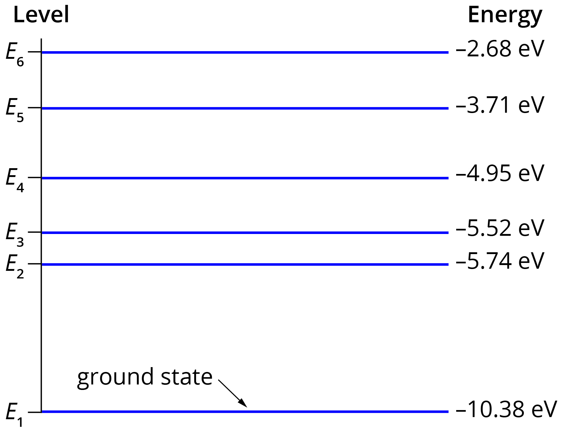
a The line emission spectrum for mercury has a prominent blue line at about 437 nm. Determine between which two energy levels an excited electron will transition to emit light of this wavelength. (4 marks)

Description | Marks
c = λf | 1
E = hf = 6.63 × 10⁻³⁴ × 6.68 × 10¹⁴ = 4.55 × 10⁻¹⁹ J | 1
 | 1
Recognition that transition is for an electron to fall from level 6 to level 3 | 1

b How many different lines could appear in mercury’s emission spectrum for an electron falling from energy level 4 to the ground state? (2 marks)

Description | Marks
6 lines in total emitted  - recognition of E₄ to E₁, E₄ to E₂, E₄ to E₃  - recognition of E₃ to E₂, E₃ to E₁, E₂ to E₁ | 1  1

Question 8
X-rays can be produced when a high-speed electron strikes a metal target and the electron’s energy is converted to X-rays.
a If an electron with energy of 1.18 × 10⁶ eV produces a photon of maximum possible energy on impact with the target, what is the frequency of the X-ray? (3 marks)

Description | Marks
E = 1.18 × 10⁶ × 1.6 × 10⁻¹⁹ = 1.888 × 10⁻¹³ J | 1
E = hf | 1
 | 1

b Some minerals fluoresce red when X-rays are shone onto them. Explain how this occurs. (2 marks)

Description | Marks
Electrons in the mineral’s atoms absorb energy and are excited up at least two energy levels. | 1
The electrons return to the ground state in a series of steps that have energy lower than that of X-rays. In this case, the emitted energy is in the red region of the EM spectrum. | 1

Question 9
The Bohr model of the hydrogen atom assumes its electron can only orbit the nucleus at certain fixed distances. Explain how de Broglie’s model of wave–particle duality of all matter can be used to support the idea of fixed orbits (or more correctly, fixed orbitals). (2 marks)

Description | Marks
Recognition that electrons can behave as waves in the atom. | 1
Recognition that the circumference of allowed ‘orbits’ around the nucleus correspond to a whole number of electron wavelengths, meaning the orbit is a standing wave. | 1

Question 10
What is the wavelength of an electron with kinetic energy of 40 eV? (5 marks)

Description | Marks
E = 40 × 1.6 × 10⁻¹⁹ = 6.4 × 10⁻¹⁸ J | 1
 | 1
 | 2
 | 1

Question 11
Using appropriate estimates for a familiar macroscopic object and the appropriate mathematical relationship, explain why we do not experience the wave–particle duality for macroscopic objects. (4 marks)

Description | Marks
Recognition that estimates need to be made for the object’s mass and velocity | 1
Estimates of mass and velocity for chosen object are appropriate | 1
Application of | 1
Statement showing recognition of the very small wavelength making it negligible | 1

